NIHVA’s ENTERENCE GATES

- Motorized Sliding gates.
- Motorized Telescopic gates.
- Motorized Cantilever gates.
- Motorized Swing gates.

- Motorized Sliding gates:
Operation: - Sliding gates move on a rail that is normally fixed on the ground. These swing gates moves in a horizontal way compared to the normal swing gates. A motorized sliding gates which operates by a motor and a transmitter to control the gate's movements, as per your choices, as well as manually.
USP: -
- Smooth safe and efficient operation.
- Varied lengths of gates can be fabricated. (Range 1000mm to 12000mm)
- Maximum capacity up to 18000kgs. Can be fabricated
- Bottom rail made up of polished bright bar supported with heavy duty beam.
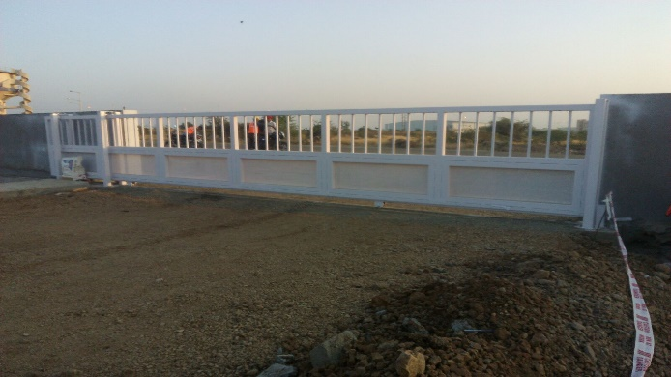
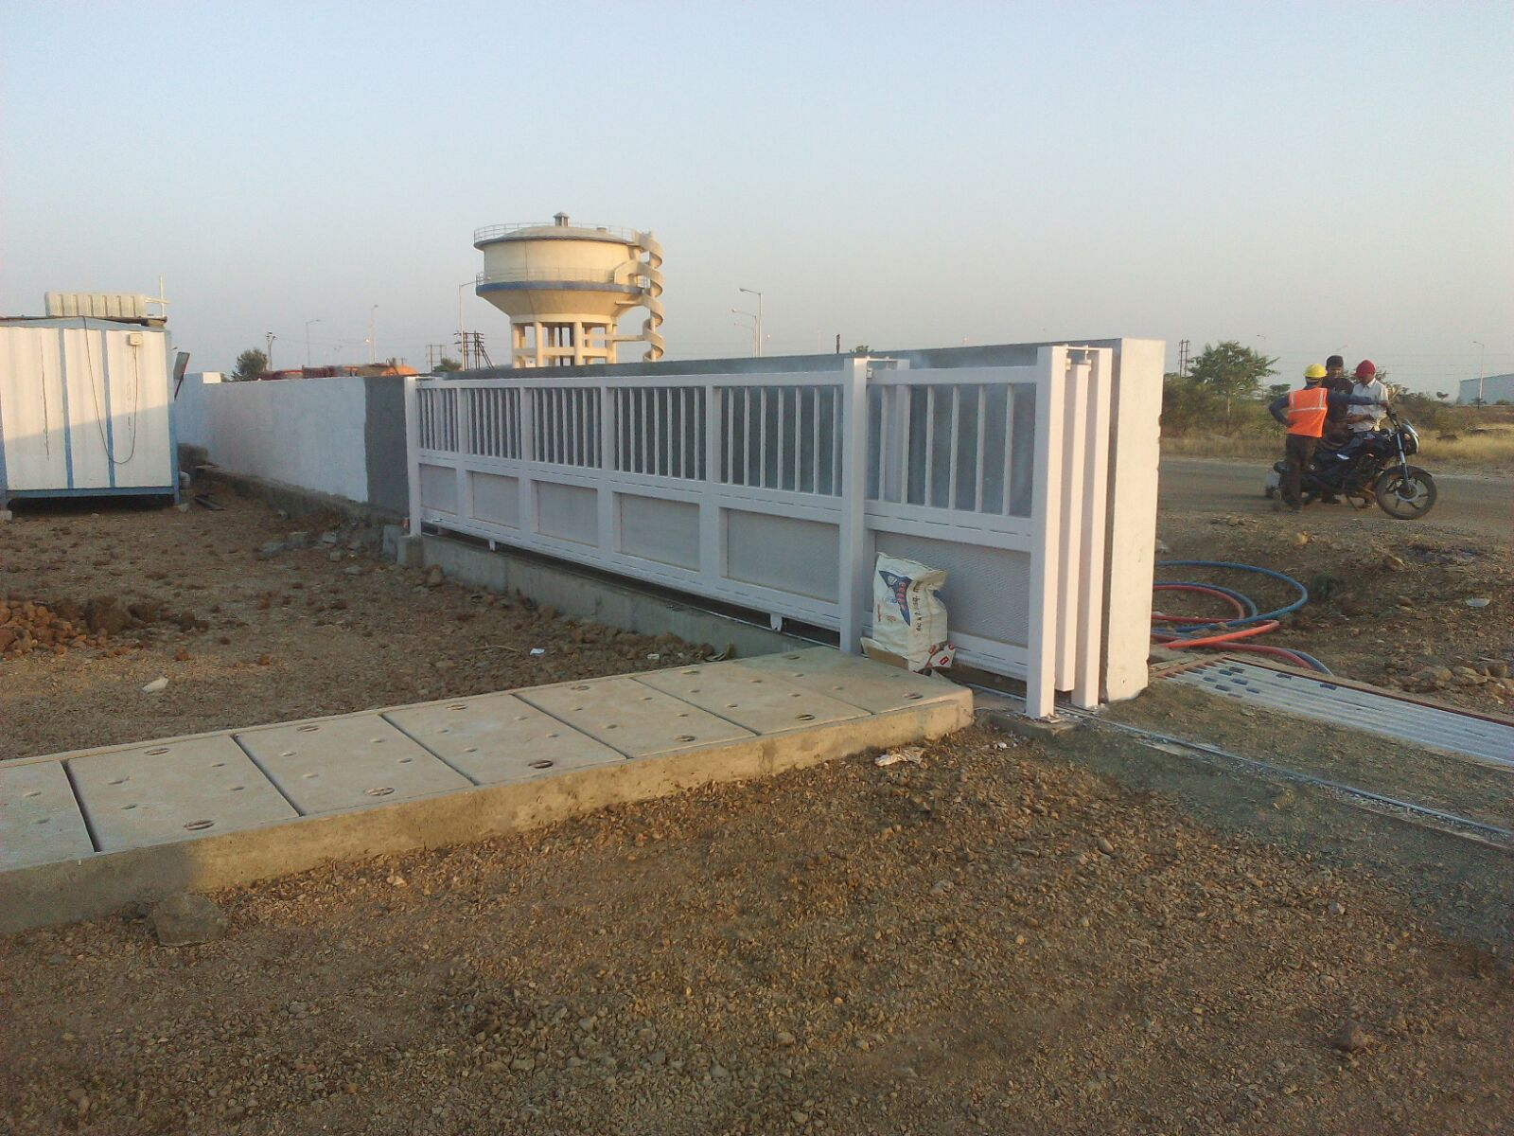
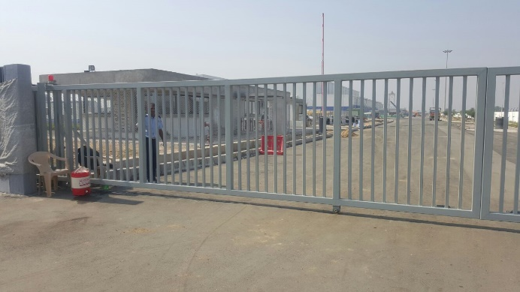
- Motorized Telescopic gates:-
Operation : - When a conventional single side or double side sliding gate arrangement is not possible due to very less or no run-way or track to move, telescopic sliding gates system is the perfect solution for extra wide opening areas. Three or more gates panels and therefore reduce the required back run or parking space, with multiple leaves moving simultaneously.
USP:-
- Space Efficient: - it designed to retract and expand horizontally, requiring less space for operation compared to sliding or swing gates.
- Enhanced Security: Telescopic gates offer a high level of security due to their robust construction and design.
- Customization and Adaptability: Telescopic gates can be customized to fit specific site requirements. Whether it's a wide entrance or a limited space.
- Quick and Smooth Operation: - These gates are often equipped with advanced automation systems, allowing for quick and smooth opening and closing.
- Integration with Access Control Systems: telescopic gates can be easily integrated with various access systems. This enhances the overall security infrastructure of industrial facilities.
- Aesthetically Pleasing Design: Beyond functionality, telescopic gates often come in modern and aesthetically pleasing designs.
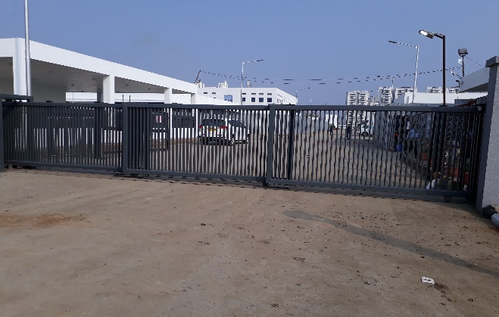

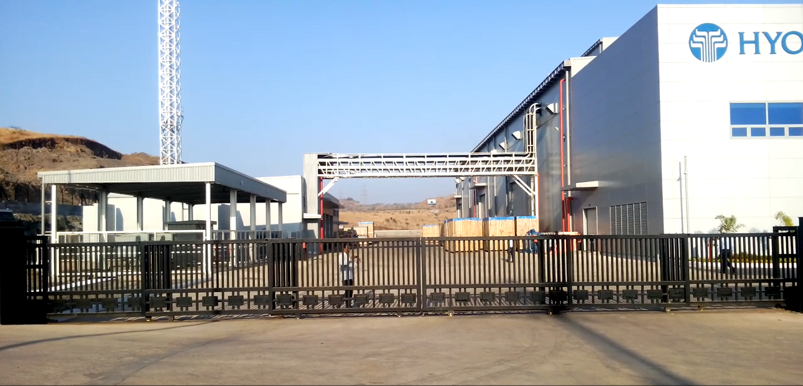
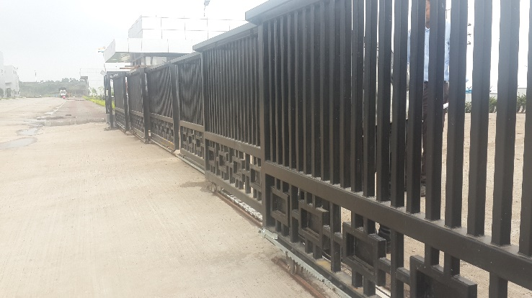
- Motorized Cantilever gates:-
Operation: - Cantilever gates are a type of sliding gate that operate by sliding horizontally along a track, which is located on the ground besides the gate opening. They are supported and balanced by a counterbalance system, which is installed on the opposite side of the gate opening. The gate is not prone to getting blocked by leaves or dirt hence reduced maintenance.
- Smooth and quiet operation.
- Low maintenance.
- Deal for uneven or sloping road surfaces.
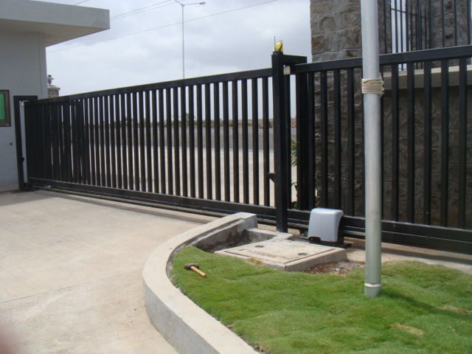
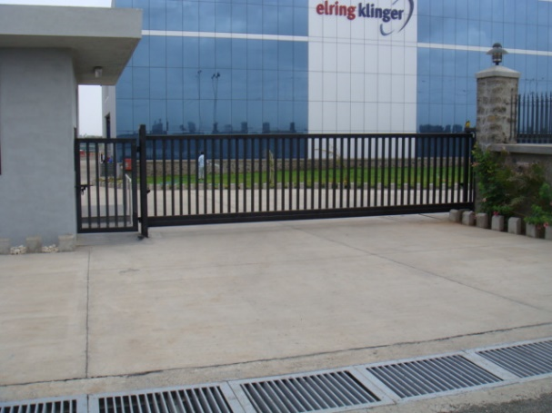
- No blockages.
- Motorized Swing gates:-
Operation: Swing gates are a type of gate that open and close automatically with the help of electronic, hydraulic or mechanical devices called swing gate operators. They reduce the need for humans to open and close the gate, and are increasingly becoming a mainstay in shared facilities, such as airport terminals
USP:-
- Automated Operation
- Security, Traffic control, Flexibility in operation.
- Operation of manual or motorized
- Wide opening (1000mm to 12000mm)
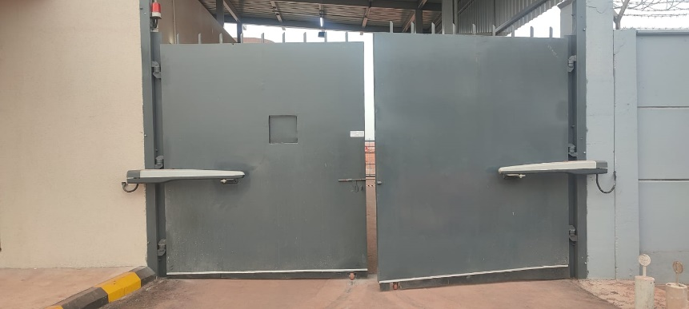
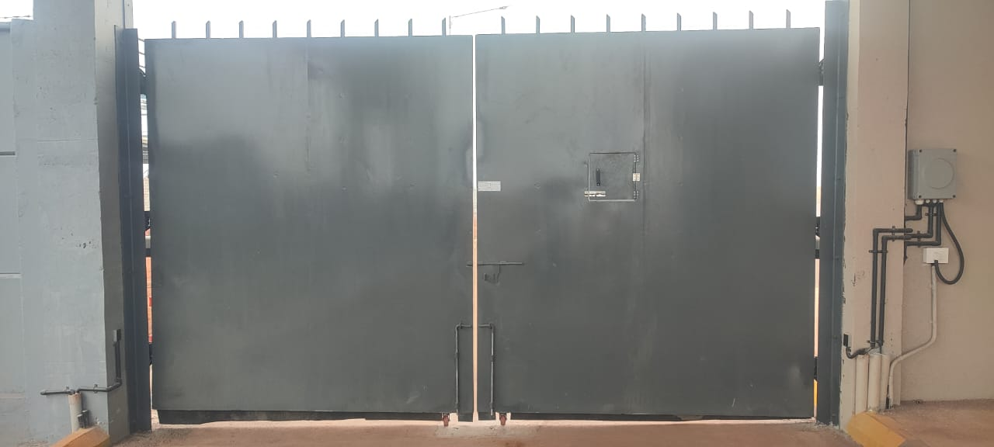
- Bottom roller wi th high pre cision bearing.

